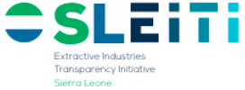
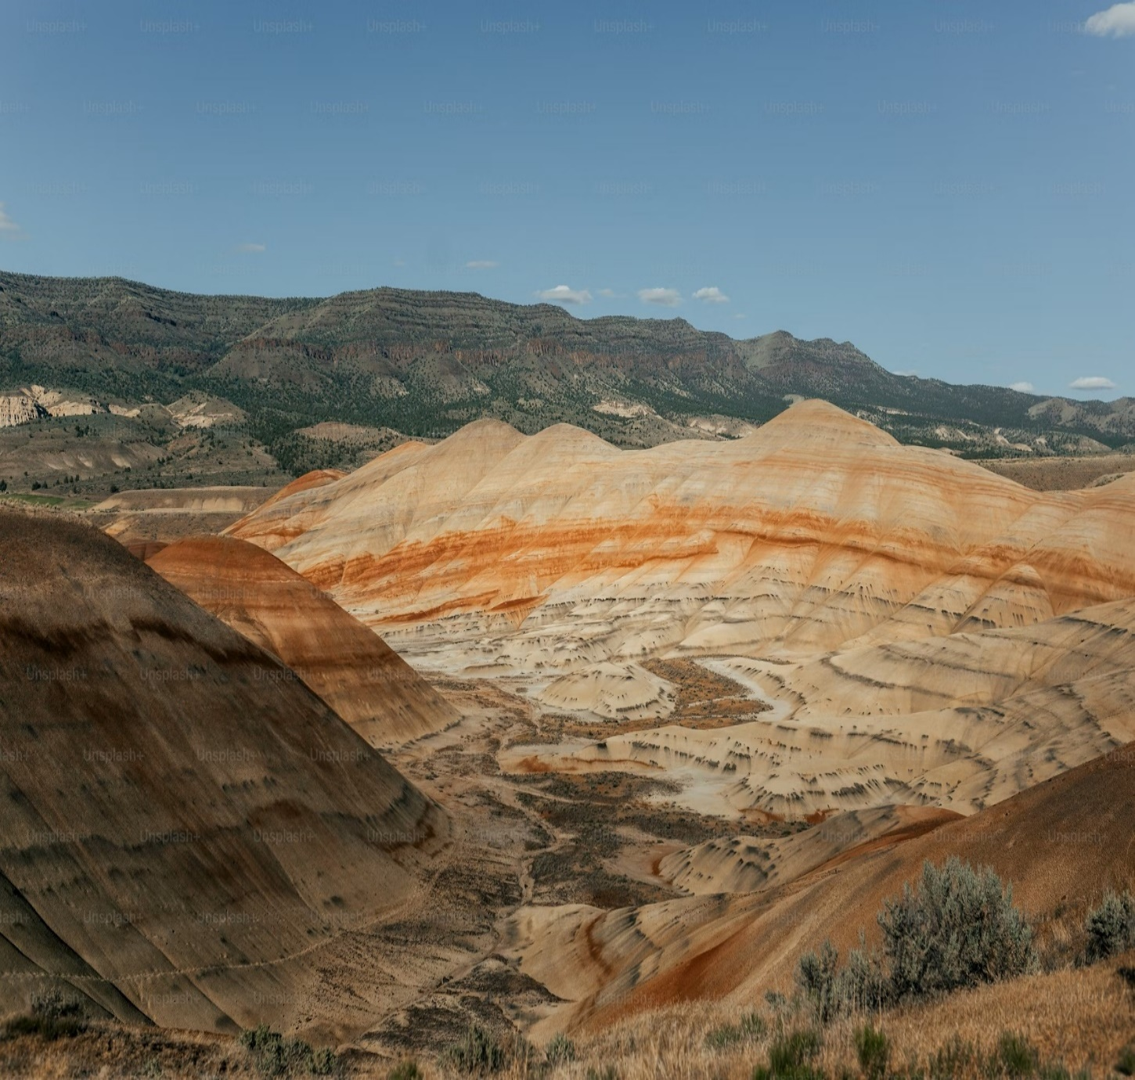

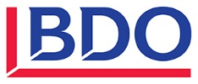
SIERRA LEONE EXTRACTIVE INDUSTRIES TRANSPARENCY INITIATIVE (SLEITI)

EITI Summary REPORT
2022-2023

24 January 2025

This report has been prepared at the request of the Multi-Stakeholder Group (MSG) in charge of the implementation of the SLEITI. The opinion expressed in the report are those of the Independent Administrator and the report has been approved by the SLEITI MSG. This report has been prepared exclusively for use by the Sierra Leone Extractive Industries Transparency Initiative (SLEITI) and must not be used by other parties, nor for any purposes other than those for which it is intended.

Extractive Industries Transparency Initiative (EITI)

Background
The Extractive Industries Transparency Initiative (EITI) was first announced at the World Summit on Sustainable Development in Johannesburg in 2002 (the Earth Summit 2002) and was officially launched in London in 2003.
It is a global Standard to promote open and accountable management of natural resources. It seeks to strengthen government and company systems, inform public debates, and enhance trust. In each implementing country, it is supported by a coalition of governments, companies operating in the extractive sector and civil society organisations working together.

Evolving normative framework (2003-2023)
EITI reports should be prepared based on the 2023 EITI Standard (here in after referred to as the “The EITI Standard”). This is the fourth version of the Standard since the 2013 one. Please see Figure 1 below.
The EITI Standard has evolved to respond to stakeholder needs and a changing global context. Now it includes several new and refined provisions that enable countries to respond to the most pressing challenges that concern natural resource governance today.
These broadly cover four thematic areas:
- Anti-corruption: Enhance the ability of countries and companies to use the EITI platform for the identification and management of corruption risks in the natural resource sector.
- Energy transition: Supporting disclosure and public debate on the implications of energy transition by highlighting relevant policies, as well as revenues countries can expect from their oil, gas and minerals under different market scenarios.
- Gender, social and environmental issues: To help ensure that natural resources are managed in the interests of all citizens, there are stronger provisions to promote greater diversity in decision-making and disclosure, considering gender, social and environmental issues.
- Revenue collection: New and refined provisions require more comprehensive and detailed disclosures, which can help countries strengthen their tax base and raise revenues.
For further information about the 2023 EITI Standard, please refer to the summary of changes the EITI International Secretariat prepared in June 2023.
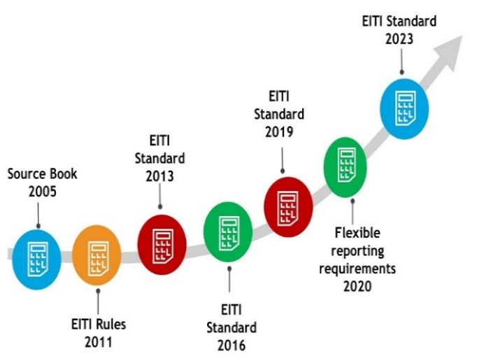
Figure 1: Evolving normative framework (2003-2023)

EITI in Sierra Leone
The Government of Sierra Leone (here after referred to as “GoSL”) first announced its intention to join the EITI programme in June 2006 to promote transparency and accountability in the management of its mineral resources. The country formed its first multi-stakeholder group (MSG), the Sierra Leone Extractive Industries Transparency Initiative (SLEITI) in June 2007. Sierra Leone became an EITI Candidate in February 2008, and it became a compliant country in 2014.
The SLEITI Multi-stakeholder Group (MSG) is a tripartite body comprising mining companies, civil society organisations (CSOs) and government representatives who are mandated to promote the integration of EITI into broader transparency efforts where the citizens take ownership of the EITI process.
The SLEITI MSG is responsible for developing policies and programmes that align with the EITI Standard and reflect national priorities, oversee the EITI reporting process, approve work plans and effectively undertake outreach activities on necessary information that emanate from the EITI Process.
As part of its implementation, Sierra Leone has published twelve (12) EITI reports covering 2007 to 2023.
In October 2022, The EITI Board concluded that Sierra Leone had achieved a high overall score (87.5 out of 100 points) in EITI implementation. Despite challenges related to COVID-19, the country had used the EITI to engage with host communities and drive reforms in the extractive sector.
The next validation will commence in January 2027 in accordance with the validation schedule.

Revenues generated from the extractive sector
Based on the data collected from government agencies and extractive companies, the total revenues generated from the extractive sector in Sierra Leone (including social and environmental expenditure) amounted to US$ 39 million (Le 0.7 bn) and US$ 48 million (Le 1.1 bn) respectively in 2022 and 2023, a year-on-year increase of US$ 9 million or 22%.

Review of the extractive revenues between 2019 and 2023
The average annual decrease of extractive revenues between 2017 and 2021 was 8%. Revenues dropped by 43% between 2021 and 2022 because of the sharp drop in diamonds activity. During 2023, the figures improved compared with 2022 as new mining companies entered into activity.
The Figure below shows the trend of the extractive revenues over five years (2017-2021).
Figure 2: Trend of The Extractive Revenues Between 2019 and 2023 (in US$ million)

Breakdown by type of revenue
Analysis of the extractive revenues by type indicates that tax revenues represented approximately 85% of the total revenues collected in 2022 and 2023. Surface rent paid by extractive companies to sub-national agencies accounted for less than 1%, while social and environmental payments represented 15%. The table and Figures below present the contribution by type of revenue.

Table 1: Breakdown of Extractive Revenues by Type of Payment (2022 and 2023)
In US$ million | Disclosed by | 2023 | % | 2022 | %
Tax revenues from in-scope companies | Government agencies | 37.36 | 77.77% | 29.78 | 75.83%
Tax revenues from out-of-scope companies | Government agencies | 3.38 | 7.04% | 4.42 | 11.25%
Surface rent | Sub-national agencies | 0.26 | 0.54% | 0.31 | 0.78%
Total tax revenues |  | 41.00 | 85.35% | 34.50 | 87.85%
Social payments | Mining companies | 6.31 | 13.13% | 3.86 | 9.83%
Environmental payments | Mining companies | 0.73 | 1.52% | 0.91 | 2.32%
Total social and environmental payments |  | 7.04 | 14.65% | 4.77 | 12.15%
Total |  | 48.03 | 100.00% | 39.28 | 100.00%
Figure 3: Breakdown of Extractive Revenues by Type of Payment (2022) | Figure 4: Breakdown of Extractive Revenues by Type of Payment (2023)

Analysis of production data
The mining production value has increased by more than 33% between 2022 and 2023 reaching US$ 1.1 billion (Le 27.8 billion) in 2023. The table below shows the growth in production value by commodity.
Table 2: Growth of Total Value of Mining Production Between 2022 and 2023
In US$ Million | 2023 | 2022 | Variation | %
Iron ore | 755 | 470 | 285 | 60.76%
Rutile | 139 | 177 | (38) | (21.71%)
HMC | 78 | 103 | (26) | (24.87%)
Diamond | 75 | 21 | 54 | 264.75%
Bauxite | 44 | 28 | 16 | 56.17%
Ilmenite | 13 | 16 | (3) | (19.93%)
Zircon | 12 | 24 | (12) | (50.61%)
Gold | 7 | 6 | 1 | 16.65%
Total | 1,123 | 845 | 277 | 32.79%
Source: NMA
The Figure below shows the trend of the mining production value over five years (2019-2023).
Figure 5: Growth of Total Value of Mining Production Between 2019 and 2023 (in US$ million)
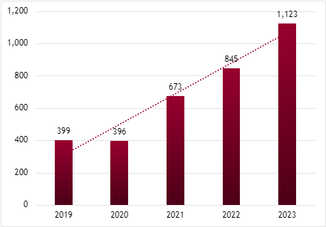
CAGR 29.52%

Analysis of export data
The mining exports value increased by 33% between 2022 and 2023 reaching US$ 1.2 billion (Le 27.3 billion) in 2023. The table below shows the evolution of the production value by commodity.
Table 3: Growth of Total Value of Mining Exports Between 2022 and 2023
In US$ Million | 2023 | 2022 | Variation | %
Iron Ore | 835 | 478 | 357 | 74.58%
Rutile | 154 | 194 | (41) | (20.90%)
HMC | 74 | 24 | 49 | 203.93%
Diamond | 67 | 103 | (36) | (35.43%)
Bauxite | 44 | 28 | 16 | 55.93%
Ilmenite | 13 | 16 | (3) | (17.70%)
Zircorn | 8 | 68 | (60) | (88.55%)
Gold | 4 | 24 | (21) | (85.13%)
Garnet | 1 | 1 | 1 | 100.00%
Total | 1,199 | 937 | 262 | 27.96%
Source: NMA
The Figure below shows the trend of the mining exports value over five years (2019-2023).
Figure 6: Growth of Total Value of Mining Exports Between 2019 and 2023 (in US$ million)
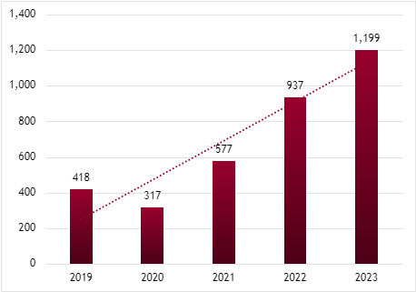
CAGR 30.12%

Contribution of the extractive sectors to the economy in 2022-2023
The figure below shows the contribution of the extractive sectors to the economy of Sierra Leone in 2022 and 2023.
Figure 7: Contribution of The Extractive Sectors to The Economy in 2022 and 2023
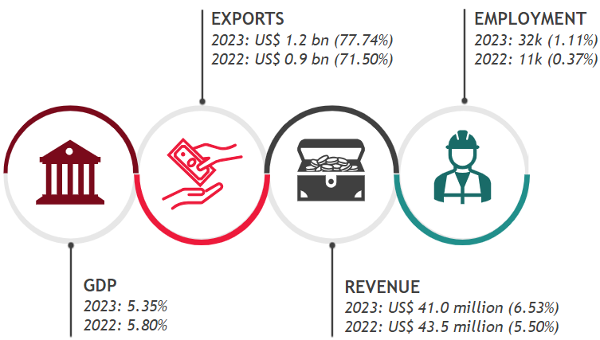

Contract and license allocations

Mining sector
We present in the table below the types of mining licenses in Sierra Leone, their duration and rights conferred by each type of mining license.
Table 4: Types of Mining Licenses
Type | Duration | Rights conferred
Reconnaissance License | One year renewable once | A reconnaissance license is the first stage in the mining enterprise entitles the holder to search for all minerals by geological, geophysical, and geochemical means. In general, reconnaissance licenses do not allow drilling, excavation, or other physical activities on the land, except where such activity is specifically mentioned by the license. A reconnaissance area shall not exceed 10,000 km².
Exploration License | Three years, renewable twice (for 2 years each) | Exploration licenses which cover the second stage of mining operations entitle the holder to search for the stipulated minerals and to determine their extent and economic value.  The size of the concession granted for the first 3 years is a maximum of 250 km². This size is halved (i.e. 125 km²⁾ from the 4th year onwards. 90 days prior to the expiry of the exploration license, the holder shall apply for a small-scale, large-scale mining license or a combination of both without overlap.
Small Scale Mining License | Limited to four years, renewable over the commercial life of the deposit. | Between 50 and 200 hectares.  The holder of a small-scale-mining license shall have the exclusive right to carry on exploration and mining operations in the licensed area.
Large Scale Mining License | Limited to 25 years renewable for a period limited to 15 years | The holder of a large-scale mining license shall have the exclusive right to carry on exploration and mining operations in the large-scale mining license area.
Artisanal Mining License | One year, renewable on an annual basis | An artisanal mining license area shall not be more than 2.5 acres.  The holder of an artisanal license shall have the exclusive right to carry on exploration and mining operations in the licensed area.
Source: Mines and Minerals Development Act (MMDA, 2023 Act)

Oil and Gas sector
There are two types of oil and gas licences: Reconnaissance permits and petroleum licences.
Table 5: Oil and Gas Licences
Type | Duration | Rights conferred
Reconnaissance permit | Specified in the reconnaissance permit | A non-exclusive right to undertake reconnaissance operations in the permit area.
Petroleum license | 30 years from the effective date, unless sooner cancelled or terminated | An exclusive right to undertake exploration and production within a license area.
Source: PEPA (2011)
The table below shows the award process of each type of oil & gas licence:
Table 6: Oil and Gas Award Process
Type | Awarded by | Award process
Reconnaissance permit | The Minister on the advice of the Directorate | A company or group of companies may, upon payment of the prescribed non-refundable application fee, apply to the Minister for a reconnaissance permit.
Petroleum License | The Minister | The Minister may prescribe a petroleum license shall be acquired through:  - a call for tenders; or  - direct negotiations.
Source: PEPA (2011)
The table below details the licensing process:
Table 7: Oil and Gas Award Process (Detailed)
Step | Description
1 | Expression of interest by applicant company
2 | Submission of Application for pre-qualification.
3 | Preliminary assessment and prequalification of applicant
4 | Applicant to visit data room in Freetown or London and identify area of interest
5 | Submission of Application
6 | Constitution of multi sectorial Evaluation Committee comprising representatives of Office of President, Petroleum Directorate, Ministry of Finance, Office of Attorney General and Minister of Justice, Environmental Protection Agency, Local Content Agency
7 | Design and approval of evaluation instrument
8 | Further due diligence by sub-committee
9 | Evaluation and ranking of applicants if there is competition for Blocks
10 | Grant of provisional Licence subject to outcome of Negotiation
11 | Announcement of evaluation outcome
12 | Multi sectoral negotiation committee constituted, comprising representatives of Office of President, PD-SL, Ministry of Finance, Office of Attorney General and Minister of Justice
13 | Face-face or virtual negotiation held
14 | Signing of Agreement
15 | Parliamentary ratification
Source: PEPA (2011)

Contract Disclosure

Mining Sector
The full text of the active MLAs above was published on NMA and Resource Contract website.
The online cadastral system provides information on license holder, coordinates of the licensed areas, date of application award and duration of the license as well as the commodity being produced. However, we noted that the full text of mining licenses and the license templates are not publicly available.

Oil and Gas sector
At the time of writing, no petroleum agreement had been published on the Petroleum Directorate website or other websites.
However, the models of the Petroleum Licence Agreement and Reconnaissance Permit Agreement that might be used in case of agreement with petroleum companies are available on the Petroleum Directorate website.

Register of mining licenses
Sierra Leone has an online cadastre system, the Mining Cadastre Administration System (MCAS) which provides information on the following with the view to ensuring transparency in the management of minerals rights. This online repository of mining licenses contains data on all issued mineral rights, exploration, mining, as well as dealers and export licenses, related payments (type of license, license holder, license code, status active/non active, coordinates, start date, expiry date, application date, the commodity being produced, etc.).
Open to the public, the system is further linked to the tax authority’s systems. This system allows the tax authority to publish revenues from the sector online and therefore makes a significant contribution to transparency efforts in license management.
The data is published directly from the Mining Cadastre Administration System (MCAS), where all licenses are managed by the Mining Cadastre Management Unit (MCMU).
Coordinates are provided in online MCAS.

Register of petroleum licenses
Section 117 of PEPA (2011) prescribes that the Minister should maintain a register of permits and licenses granted under PEPA (2011). A person may, upon the payment of the prescribed fee, inspect the register or take copies of an entry in the register.
There is currently no publicly available register or cadastre in the oil & gas sector as required by EITI requirement 2.3 (b).
According to the PD-SL, the following are the active holders of petroleum licences during 2022 and 2023:
Table 8: Petroleum active licenses during 2022 and 2023
Company | Award date | Duration | Blocks
INNOSON Oil & Gas Ltd | 16/12/2020 | 30 years | 96-97-114- 115-116-117-133-134-135
F.A. Oil Ltd | 04/12/2023 | 30 years | 53-54-55-72-73-74

Sub-national payments
In application of EITI Requirement 4.6, mining companies perform direct payments to subnational government agencies in accordance with Section 36 (A) of the MMDA (2023) that stipulates that Surface Rent is a sub-national payment made by companies or holders of mining licenses and which should be shared amongst four categories of recipients as follows:
- Landowners;
- Paramount chiefs;
- District councils; and
- Constituency development fund.
Figure 8: Surface rent allocation under the MMDA (2023)
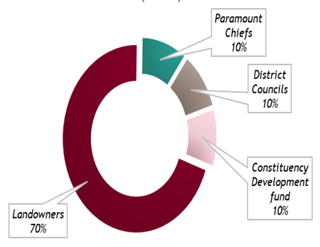

Sub-national transfers

Diamond Area Community Development Fund (DACDF)
The SLEITI MSG agreed that the DACDF is a sub-national transfer in Sierra Leone. DACDF was formally approved by Sierra Leone’s Ministry of Mineral Resources in December 2001, as part of a broader reform programme for the diamond sector initiated after the end of the civil war. The main funding of DACDF consists of 25% of the government’s 3% diamond export tax.
The DACDF reported Le 3.6 million of transfers in 2022. The table below shows a comparison of the amount due of transfers to DACDF (i.e., 25% of the total Diamond Export duties) between 2022 and 2021:
Table 9: Amount due of the Transfers to DACDF
In Leones | 2022 | 2021 | Variance
Amount due of the transfers to DACDF | 3,609,002 | 4,245,396 | (636,394)
Source: MMMR
However, no information was provided by the MMMR regarding transfers to the DACDF in 2023.
Disbursements made from DACDF during 2022 and 2023
We were not informed of any disbursement to districts/Chiefdoms made from the DACDF during 2022 and 2023. However, the MMMR provided us with disbursements made to districts/Chiefdoms in 2024 for a total amount of Le 8,854,330 as a result of the collections made in 2020, 2021 and 2022. Below is the presentation of payments by district:
Table 10: DACDF transfers by district
District | Amount  (Le) | %
Kono District | 4,075,914 | 46.03%
Kenema District | 2,839,979 | 32.07%
Bo District | 1,147,115 | 12.96%
Pujehun District | 497,194 | 5.62%
Kailahun District | 263,858 | 2.98%
Bonthe District | 25,515 | 0.29%
Moyamba District | 4,756 | 0.05%
Total | 8,854,330 | 100.00%
Source: MMMR
Figure 9: Portion of each district in DACDF transfers

Mining District Development Fund (MDDF)
Pursuant to article 144 of the MMDA, 2023, a mining district development fund shall be established to facilitate management of mining revenues for Chiefdoms of mining districts not subject to community development agreements. The MDDF established shall be administered by the MMMR in collaboration with Members of Parliament for the Mining District and the Ministries responsible for Finance, Rural Development, Planning and Economic Development, and financed by the transfer of 20% of all mining royalties.
However, no information has been made available regarding the operational status of the MDDF or any transfers to it for the period 2022 - 2023.

Beneficial Ownership (BO)

BO disclosure requirements in the extractive sector
Mining sector
Section 160 of the MMDA, 2023 Act stipulates that the holder of a reconnaissance license, exploration license, large-scale mining license or small-scale mining license shall disclose details of persons holding a participating interest in the license. A person who holds a 5% or more interest shall be defined as holding a "participating interest" in the shares and shall declare such interests to the NMA and other authorised institutions. The details of such persons shall include the full name, nationality and country of origin and percentage / number of shares held.
Oil and gas
Section 21 (a) of the Petroleum (Exploration and Production) Act 2011 dictates that an application for a reconnaissance permit shall contain the name of each person who is the beneficial owner of 5% or more of the shares issued by the company or companies. Section 37 of Petroleum (Exploration and Production) Act 2011 dictates the same regarding applications for a petroleum license.
All sectors
For non-extractive activities, the Companies Act (2009), which set up the Corporate Affairs Commission (CAC), and the 2014 Amendments to that Act, give powers to the CAC to request and receive BO information from companies. However, this is limited only to public companies. (i.e., private companies are not then required by law to disclose BO information).

Progress made on BO
In November 2024, SLEITI held a meeting with the National Investment Board (NIB) to explore establishing a BO national register. This initiative is part of efforts to improve transparency and accountability in Sierra Leone's extractive industries and investment sectors.
Key highlights from this meeting include:
- Partnership and collaboration: SLEITI and NIB will jointly develop BO disclosure regulations, working alongside the Bank of Sierra Leone, Anti-Corruption Commission, Financial Intelligence Agency, etc.
- Regulatory reforms: Develop a regulation to require BO disclosures from both public and private companies, strengthening the foundation of BO regulation in Sierra Leone.
- Technical Working Group reactivation: A dedicated BO technical working group will be reactivated to drive policy and regulatory reforms, ensuring comprehensive BO disclosure.
- Data collection: NIB will gather BO data as part of its investment vetting process, enhancing investor confidence while ensuring transparency in Sierra Leone’s business environment.

Environmental impact of extractive activities
Section of 57 (1) (i) of PEPA (2011) states that: “a social and environmental impact assessment for the development area has to be approved in accordance with the Environmental Protection Act 2008”.
The MMDA (2023) requires mining companies to acquire Environmental Impact Assessment (EIA) licences before they can be granted mining licences. It also requires every mineral rights holder to protect the environment and carry out operations in a way that will minimise and manage negative environmental impact.
Pursuant to article 134 of the MMDA (2023), mining companies are required to submit annual reports on environmental and social impacts and mitigation actions. These reports hall be made available to the public including but not limited to:
- environmental screening reports;
- environmental impact assessments; and
- environmental and social management plans.

National Commitments to the Energy Transition
Sierra Leone has made a series of commitments to the global energy transition, with a focus on increasing the share of renewable energy, improving energy access, and addressing climate change. Below are some of the key actions and commitments made by the government of Sierra Leone:
First National Dialogue on Energy Transition
In October 2023, Sierra Leone's President convened the First National Dialogue on Energy Transition, a significant step toward shaping the country's energy future. The dialogue brought together key stakeholders, including government officials, private sector actors, civil society, and development partners, to discuss and commit to a comprehensive energy transition plan. During the dialogue, several key commitments were made to accelerate the transition towards a sustainable and resilient energy system for Sierra Leone.
Climate Resilience and Energy Transition Dialogue (CRET 2024)
In November 2024, The Office of the Presidential Initiative on Climate Change, Renewable Energy, and Food Security (PI-CREF), in partnership with key ministries hosted the second edition of a two-day Climate Resilience and Energy Transition Dialogue (CRET 2024).
Over 400 stakeholders from the public and private sectors in energy, climate change, health, agriculture, and other productive sectors of the economy, as well as representatives from CSOs and academia attended the dialogue.
Launch of the Energy Transition and Green Growth Plan
Following the Climate Resilience and Energy Transition Dialogue in November 2024, the GoSL launched an ambitious Green Growth Plan, marking a significant step towards achieving 100% electrification by 2040. The plan aims to transition the country to sustainable energy sources, including hydropower and solar, while reducing reliance on biomass and oil. This initiative is aligned with Sierra Leone’s broader climate goals and development strategies, including its Nationally Determined Contributions (NDCs).
Nationally Determined Contributions (NDCs) under the Paris Agreement (PA)
As a signatory to the Paris Agreement, Sierra Leone has committed to reducing its greenhouse gas emissions and transitioning to a more sustainable energy system.
Sierra Leone’s NDC responds to Article 4, paragraph 2 of the PA, which requires parties to the United Nations Framework Convention on Climate Change (UNFCCC) to prepare, communicate and maintain successive Nationally Determined Contributions (NDCs) that they intend to achieve.
The NDC serves as an instrument to guide the country’s climate actions of the various mitigation and adaptation options in reducing GHG emissions and accompanying climate change challenges.
The table below shows the Nationally Determined Contributions (NDCs) submitted by the GoSL to fulfill its commitments under the Paris Agreement and the United Nations Framework Convention on Climate Change (UNFCCC):
Table 11: Sierra Leone Nationally Determined Contributions (NDCs)
Document | Submission date | Link
Intended Nationally Determined Contribution (INDC) | 01/11/2016 | Link
Updated Nationally Determined Contribution (Updated NDC) | 31/07/2021 | Link
National Adaption Plan (NAP) Process
Sierra Leone’s commitments under the National Adaptation Plan (NAP) process are vital components of the country’s broader strategy to address the impacts of climate change, particularly in the context of its energy transition.
The NAP process is a structured approach that allows countries to plan, implement, and monitor their adaptation efforts over time. It is aligned with the United Nations Framework Convention on Climate Change (UNFCCC) and is designed to support developing countries like Sierra Leone in their long-term adaptation strategies.
The key tools under the NAP process are the National Adaptation Plan (NAP), National Communications (NC), and Biennial Update Reports (BURs), each playing a distinct role in supporting climate resilience efforts.
National Adaptation Plan (NAP)
The NAP serves as the primary tool for identifying and planning for climate change adaptation at the national level. It outlines the country’s long-term goals, strategies, and sector-specific actions to reduce vulnerabilities and enhance resilience to climate impacts.
National Communications (NC)
The NC is a reporting tool that allows countries to communicate their climate actions to the UNFCCC.
Biennial Update Reports (BURs)
The BURs provide regular updates on the country’s progress in implementing its climate change actions, including both mitigation and adaptation measures.
Below is a summary of NAPs, NCs and BURs submitted by Sierra Leone to UNFCCC:
Table 12: Sierra Leone National Adaptation Plan (NAP) documents
Document
Initial National Adaptation Plan (INAP), 2021
Third National Communication (NC 3)
Second National Communication (NC 2)
First National Communication (NC 1)
First Biennial Update Report (BUR 1), 2024
International Partnerships
In 2020, Sierra Leone joined the NDC Partnership, a global coalition of countries and institutions working together to achieve ambitious climate goals under the Paris Agreement. The partnership focal institutions in Sierra Leone are the Environment Protection Agency (EPA-SL) and the Ministry of Planning and Economic Development (MoPED).
Through this membership, Sierra Leone seeks to strengthen its capacity to implement its Nationally Determined Contributions (NDCs) by accessing technical and financial support. The NDC Partnership helps Sierra Leone to mobilise funding for renewable energy, sustainable agriculture, reforestation, and climate adaptation initiatives. It facilitates connections with international donors, development partners, and global climate funds such as the Green Climate Fund (GCF) and the Global Environment Facility (GEF).

Involving the Private Sector
The GoSL is actively involving the private sector in the country's energy transition through several initiatives. These efforts aim to increase renewable energy capacity, attract investment, and provide sustainable energy access across the country, including:
- Engagement with the Mining Sector: The government is encouraging mining companies to transition from diesel generators to grid-connected renewable energy, ensuring a steady demand for clean energy and enhancing the viability of private investments. Mining companies, which currently self-generate 500 MW using diesel, are required to connect to the national grid by 2040 to enhance demand for renewable energy investments.
- Public-Private Partnerships (PPPs): The PPP Unit in Sierra Leone was established in 2014. Its creation was aimed at enhancing the country's infrastructure development by fostering collaboration between the public and private sectors, including in the energy sector, where it plays a crucial role in supporting sustainable energy projects and facilitating the country's energy transition.
- Investment Promotion through the Sierra Leone Investment and Export Promotion Agency (SLIEPA): SLIEPA plays a key role in attracting private investments into the energy sector. By providing support to investors and showcasing opportunities in renewable energy, SLIEPA aligns its initiatives with national energy goals, particularly in scaling solar and hydropower projects, as well as improving rural electrification.
- Incentives for Private Investors: The government is also providing special financial incentives to investors in the renewable energy sector. These include duty-free importation of renewable energy equipment, tax exemptions for projects meeting specific investment thresholds, and support for mini-grid and off-grid solutions.
Energy Sector Institutional Reforms
To ensure the effectiveness of its energy transition, Sierra Leone is reforming its energy sector, including improvements in governance, regulatory frameworks, and sectoral coordination.
Key reforms include the creation of the Electricity and Water Regulatory Commission (EWRC) in 2014, which plays a central role in regulating tariffs and overseeing the relationships between electricity providers, including the Electricity Generation and Transmission Company (EGTC) and Independent Power Producers (IPPs).
The restructuring of the National Power Authority (NPA) into EGTC and the Electricity Distribution and Supply Authority (EDSA), in 2015 was another crucial step. EGTC is responsible for electricity generation and transmission, while EDSA, holding a monopoly as both the sole buyer from IPPs and the sole seller to consumers, plays a pivotal role in electricity distribution.

Fight against Corruption
Sierra Leone has established a legal and institutional framework to combat corruption and financial crimes. These mechanisms address various facets of corruption, including public sector integrity, financial accountability, money laundering, and the financing of terrorism. The extractive sector, being a major contributor to the national economy, is explicitly targeted within this framework due to its vulnerability to corruption and mismanagement.
The GoSL has also shown its commitment to combating corruption through participation in initiatives such as the EITI, which ensures transparency in the management of revenues from the country’s natural resources. Additionally, Sierra Leone is a member of the Open Government Partnership (OGP), aiming to promote transparency, accountability, and citizen engagement in governance. These commitments, alongside national efforts, reflect the Government’s focus on improving governance and tackling corruption across various sectors.
Below are the key institutions for anti-corruption in Sierra Leone:
Anti-Corruption Commission (ACC)
The Anti-Corruption Commission (ACC) of Sierra Leone is an independent body established by the Anti-Corruption Act, 2008, with its primary role being to fight corruption across various sectors of society. The commission operates under the principle of ensuring accountability, transparency, and integrity in the country's public and private institutions.
Financial Intelligence Agency (FIA)
The Financial Intelligence Agency (FIA) of Sierra Leone is a government agency established to combat money laundering, terrorism financing, and other financial crimes. It operates under the mandate provided by the Anti-Money Laundering and Combating the Financing of Terrorism (AML/CFT) Act and works to safeguard the country's financial system.
Audit Service Sierra Leone (ASSL)
The Audit Service Sierra Leone (ASSL) is an independent government agency tasked with ensuring accountability and transparency in the use of public funds. It operates under the mandate provided by the Audit Service Act, 2014 and is responsible for auditing the financial activities of government institutions and public entities to promote good governance.

National Public Procurement Authority (NPPA)
The National Public Procurement Authority (NPPA) of Sierra Leone, established under the Public Procurement Act, 2004, is the regulatory body responsible for overseeing public procurement processes in the country. Its primary function is to ensure that public procurement is conducted in a transparent, fair, and accountable manner, adhering to national and international standards.
Parliamentary Oversight Committees
In Sierra Leone, Parliamentary Oversight Committees are established to monitor and review the activities of the executive branch of Government, ensuring that public resources are used efficiently, transparently, and in accordance with the law. These committees serve as a vital part of the democratic governance framework, promoting accountability and transparency within the public sector.

Gender parity in the extractive companies in Sierra Leone
According to data collected from the in-scope extractive companies, females represent only 10.9% of the workforce in the extractive sector in 2023 with 3,544 workers, compared to 1,048 female workers (9.9%) in 2022, registering thus a slight increase of 1% between 2022 and 2023.
Figure 10: Gender parity in the Sierra Leone’s extractive sector
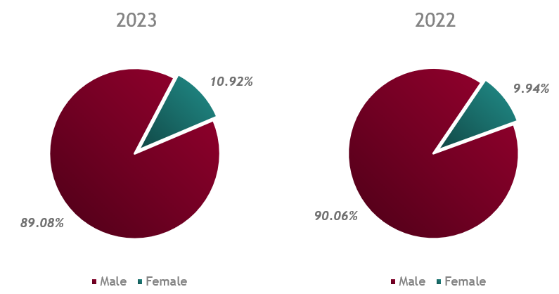

Analysis of Government Revenues from the Extractive Sector

Analysis by extractive company
2022
The analysis of tax revenues from the extractive industries shows that top 10 companies contributed almost 81% of the total revenues. Koidu Limited, Sierra Rutile Limited and Marampa Mines Ltd accounted for 57%.
Figure 11: Breakdown of Extractive Revenues by Company (2022)

2023
The analysis of tax revenues from the extractive industries shows that the top 10 companies contributed 80% of the total revenues. Marampa Mines, Koidu and Kingho Mining Company accounted for 55%.
Figure 12: Breakdown of Extractive Revenues by Company (2023)

Analysis by commodity
2022
The analysis of tax revenues from the extractive industries shows that rutile accounted for approximately 40% the total revenues.
Figure 13: Breakdown of Extractive Revenues by Commodity (2022)

2023
The analysis of tax revenues from the extractive industries shows that iron ore accounted for approximately 41% the total revenues.
Figure 14: Breakdown of Extractive Revenues by Commodity (2023)

Completeness and Reliability of Data

Data completeness
Government agencies
All in-scope government agencies have submitted their Reporting Templates (RTs).
Extractive companies
18 and 21 mining companies were selected in the scope for 2022 and 2023 respectively. However, two companies failed to submit their RTs in 2022, while five companies did not comply in 2023.
Assessment of the comprehensiveness
Based on above, we can confirm that both financial and non-financial data included in the SLEITI report for 2022 and 2023 is comprehensive.

Data quality and assurance
Government agencies
NMA, PD-SL, NRA, MMMR and EPA-SL submitted signed and certified RTs by ASSL. Additionally, we received only parts of the subnational agencies’ (district councils and chiefdoms) RTs, signed, and certified by ASSL.
Although MMMR and some of the sub-national agencies did not submit their signed and certified RTs, we can conclude that the data disclosed by government agencies was of high quality. Their contribution is less than 5% of the total government extractive revenues in 2022 and 2023, as detailed in section 1.3.c above.
Extractive companies
The contribution of non-compliant mining companies represents 3.45% and 5.55% of total government extractive revenues in 2022 and 2023 respectively. This indicates high-quality data reported by extractive companies in 2022 and medium-quality data in 2023.
Assessment of the overall data quality and assurance
Given the high quality of data reported by government agencies in both 2022 and 2023, and the high-quality data from extractive companies in 2022, along with medium-quality data from extractive companies in 2023, we can conclude the high quality of the overall data included in the SLEITI report for the years 2022 and 2023.

Recommendations
We have made recommendations with a view to improve the EITI process in Sierra Leone as well as governance and revenue management in the extractive sector.
These recommendations are as follows:
Updating data on the contribution of the informal mining sector (EITI Requirement 6.3)
The ASM contribution was not included in the extractive sector’s contribution to the economy for 2022-23 due to the lack of updated estimates available.
We recommend that further studies be conducted to document the contribution of the informal mining sector in the country’s economy. This would support MMMR and NMA to better control of the mining sector.
Public disclosure of beneficial ownership information (EITI Requirement 2.5)
In November 2024, SLEITI held a meeting with the National Investment Board (NIB) to explore establishing a BO National Register. This initiative is part of efforts to improve transparency and accountability in Sierra Leone's extractive industries and investment sectors.
We recommend expediting the BO register implementation and to put in place:
- an assurance process of information and due diligence procedures to ensure reliability of the information declared; and
- plans for developing a database that would be filled in by reporting entities systematically online.
Improving the traceability and management of sub-national transfers (EITI Requirement 5.2)
The MMMR reported LE 3.6 million of transfers to DACDF in 2022. However, no information was provided regarding transfers to the DACDF for 2023.
The MMMR provided us also, with the disbursements made to districts and chiefdoms in 2024 for a total amount of Le 8.85 million as a result of the collections made in 2020, 2021 and 2022. However, the MMMR did not provide calculation details to confirm whether these disbursements were consistent with the revenue-sharing formula or accurately reflected DACDF transfers to the respective communities.
In accordance with Article 144 of the MMDA 2023, a Mining District Development Fund (MDDF) is to be established to manage mining revenues for chiefdoms within mining districts that are not covered by community development agreements. The MDDF is to be administered by the Ministry of Mineral Resources and Mines (MMMR). It is funded through the transfer of 20% of all mining royalties.
However, no information has been made available regarding the operation status of the MDDF or any transfers to it for the period between 2022 and 2023.
The MMMR should consistently disclose all transfers to the DACDF, including those for 2023, which were not provided, to enhance transparency and accountability. This aligns with EITI Requirement 5.2, which mandates clear reporting of subnational transfers.
To comply with EITI Requirement 5.2, the MMMR should also disclose the detailed calculation methodology for DACDF transfers to each district and chiefdom. This should include the amounts collected, the basis for allocations, and how the revenue-sharing formula is applied to ensure accuracy and fairness in distributions to communities.
In addition, the MMMR should prioritise the formal establishment and operationalisation of the Mining District Development Fund (MDDF) as required by Article 144 of the MMDA, 2023. This step is essential to comply with the law and meet EITI Requirement 5.2 on subnational transfers. The MMMR should disclose details of transfers made to the MDDF, including amounts allocated, dates, and the percentage of mining royalties used. If no transfers have been made, the reasons should be clearly explained in Sierra Leone's EITI reporting.
Enhancing the licensing award process (EITI Requirement 2.2)
The IA review was performed in December 2024 at NMA premises. The required documents for the selected sample were checked, and the following deviations from the applicable legal and regulatory framework were identified:
- The technical and financial assessments for all licences awarded were not provided.
- The file of the small-scale license ‘Zhongfu Mining (SL) Ltd’ was unavailable for verification.
Despite several attempts to engage with the PD-SL, we were unable to perform the review of the awarding process for the selected license. The application documents and the technical and financial criteria that should be used during the 5th licensing round are publicly available in the PD-SL website and detailed in Section 4.2.g of the report. However, detailed information regarding the evaluation process, including the scoring for each bid and the specific criteria used for assessment, are not available.
The NMA should strengthen the document management process, to ensure that all required documents related to license awards and transfers are systematically archived and easily accessible for review.
The PD-SL should enhance stakeholder engagement by establishing structured communication protocols to ensure timely and effective responses to information requests, while aligning with EITI standards to promote greater accountability, transparency, and trust. Additionally, it is recommended that the PD-SL publish detailed information about the evaluation process during the 5th licensing offshore round, including the scoring for each bid and the specific criteria used.
We also recommend that an independent audit of the licence awards and transfers in the mining and petroleum sector be conducted. This will help improve the licensing process.
Improving the accuracy of production data (EITI Requirement 3.2)
During our review, we noted:
- discrepancies of production value and volumes between NMA and in-scope companies; and
- discrepancies of production value and volumes between the disaggregated data by commodity and the disaggregated data by company provided by the NMA for large-scale mining companies.
In order to comply with EITI Requirement 3.2, we recommend the NMA to:
- maintain updated data on production including volumes and values and the methods for calculating figures.
- improve transparency in this area by publishing production data regularly on a timely basis on its website. For example, it could publish up to date data on the Online Repository for the mining sector.
- carry out periodic reconciliations of the production values and volumes disclosed by companies and other sources. These reconciliations should be done at least quarterly, and any significant discrepancies should be fully investigated and reported to the relevant agencies.
Improving the accuracy of export data (EITI Requirement 3.3)
During our review, we noted:
- discrepancies of export value and volumes between NMA and in-scope companies; and
- discrepancies of export value and volumes between the disaggregated data by commodity and the disaggregated data by company provided by the NMA for large-scale mining companies. The tables below summarise the differences noted:
In order to comply with EITI Requirement 3.3, we recommend the NMA to:
- maintain updated data on exports including volumes and values and the methods for calculating figures.
- improve transparency in this area by publishing export data regularly on a timely basis on its website. For example, it could publish up to date data on the Online Repository for the mining sector.
carry out periodic reconciliations of the export values and volumes disclosed by companies and other sources. These reconciliations should be done at least quarterly, and any significant discrepancies should be fully investigated and reported to the relevant agencies.

For more information on EITI in Sierra Leone, see the website here.
NMA- active mining agreements
Resource Contracts- Sierra Leone
Model-Petroleum Licence Agreement
Model Reconnaissance Permit-Agreement
https://sierraleone.revenuedev.org/dashboard
Climate Resilience and Energy Transition Dialogue (CRET 2024)
https://sierraloaded.sl/news/government-green-seforall-electrification-2040/
Sierra Leone | NDC Partnership
https://www.mining-technology.com/news/sierra-leone-miners-renewable-energy/
https://ppp.gov.sl/
SLIEPA - Invest in Energy in Sierra Leone
SLIEPA - Invest in Energy in Sierra Leone
Sierra Leone - Energy Infrastructure

