
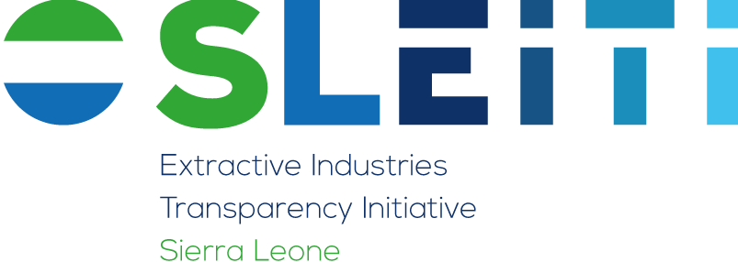
17 Charles Street, Buxton Compound, 2nd Floor,
Freetown, Sierra Leone
Website: www.sleiti.gov.sl
Office of the Vice President

SLEITI SECRETARIAT MONTHLY REPORT

PERIOD COVERED: FEBRUARY- 2024

DATE OF SUBMISSION: FEBRUARY 23RD 2024

SLEITI ACTIVITY REPORT - FEBRUARY 2024
No. | Activity | Update
1 | Recruitment of an Independent Administrator for the production of 2022-23 SLEITI Report | As part of the recruitment process of the Independent Administrator (IA) the NPPA has approved the “No objection” request submitted by the Secretariat through the OVP Procurement Unit for negotiation with the IA for reduction of the cost of production.  The fee quoted by the IA amount to USD 99,900. The fee exceeds SLEITI’s USD 85,000 budgeted for the production of the report. To achieve this, the Secretariat and the OVP Procurement Unit will convene a virtual meeting with the IA in the coming weeks to initiate negotiations of the financial bid.
2 | Draft 2024 SLEITI Work plan | In accordance with the EITI requirement, the 2024 SLEITI work plan has been developed alongside the Communications strategy and submitted to the Minister of State. It has also been shared to MSG members as part of the working documents at its planned meeting scheduled for Wednesday, 28th February 2024.
3 | OGP NAP 5 | SLEITI joined other MDAs to review the final draft Open Governance Platform (OGP) National Action Plan (NAP) 5. During the process, SLEITI submitted three Commitments which focused on a) establishment of a national BO register, b) Systematic disclosure of extractive sector data, and c) enactment of the Extractive Resources Transparency Act. These activities will be implemented over a period of four years effective 2024, and they may be reviewed from time to time where necessary.
4 | MSG Confirmation | The SLEITI MSG Memorandum of Understanding requires annual renewal of MSG members by Ministries, Departments and Agencies (MDAs). Following a correspondence to heads of MDAs, new members have been confirmed by some MDAs. The Secretariat will continue to send reminders to MDAs to resubmit the names of their MSG members.
5 | Catch up meeting with International Secretariat | The Secretariat recently held a catch-up meeting with the EITI International Secretariat to discuss implementation progress of the 2023 work plan; SLEITI 2024 priorities; and the EITI planned technical support to Sierra Leone. This meeting ended with a planned trip to Freetown by the International Secretariat to support EITI implementation including capacity building for MSG and Validation Technical Support.
6 | Audit of SLEITI activities | The Secretariat is putting documents together ahead of Audit Service Sierra Leone audit of SLEITI’s 2023 activities. One of the outstanding issues in the 2022 Audit report regarding outstanding payments of withholding taxes to NRA has now been resolved. SLEITI had technical challenges in making the payments to NRA. Considering the technical issues have now been resolved, SLEITI will continue to make prompt payments to NRA of withholding taxes deducted from suppliers.

